[](https://git-scm.com/)--distributed-is-the-new-centralized

Top of Form



Bottom of Form

* [**About**](https://git-scm.com/about)
* [**Documentation**](https://git-scm.com/doc)
  + [Reference](https://git-scm.com/docs)
  + [Book](https://git-scm.com/book)
  + [Videos](https://git-scm.com/videos)
  + [**External Links**](https://git-scm.com/doc/ext)
* [**Downloads**](https://git-scm.com/downloads)
* [**Community**](https://git-scm.com/community)

External Links

**Tutorials**

**Short & Sweet**

* [**Official Git Tutorial**](https://git-scm.com/docs/gittutorial)

The official gittutorial man page is a good place to start.

* [**Git Immersion**](http://gitimmersion.com/)

A guided tour that walks through the fundamentals of Git.

* [**Everyday Git**](https://git-scm.com/docs/giteveryday)

Learn the basics with 20 of the most common commands.

* [**Backlog Git Tutorial**](https://backlog.com/git-tutorial/)

It includes an introduction for complete beginners as well as hands-on tutorials for intermediate learners. ( [Japanese](https://backlog.com/git-tutorial/ja/) / [Korean](https://backlog.com/git-tutorial/kr/) / [Simplified Chinese](https://backlog.com/git-tutorial/cn/) / [Traditional Chinese](https://backlog.com/git-tutorial/tw/) / [Vietnamese](https://backlog.com/git-tutorial/vn/) )

**Diving Deeper**

* [**Ry’s Git Tutorial**](https://web.archive.org/web/20161121145226/http:/rypress.com:80/tutorials/git/index)

A hands-on introduction to the entire Git porcelain.

* [**Git for Computer Scientists**](http://eagain.net/articles/git-for-computer-scientists/)

A quick introduction to Git internals for people who aren't scared by words like Directed Acyclic Graph.

* [**Git Magic**](http://www-cs-students.stanford.edu/~blynn/gitmagic/)

An alternative book with the source [online](https://github.com/blynn/gitmagic/tree/master).

* [**Git: Version Control Made Easy**](https://www.packtpub.com/application-development/git-version-control-made-easy)

Use the powerful features of Git in your projects.

* [**Hands-On Version Control with Git [Video]**](https://www.packtpub.com/application-development/hands-version-control-git-video)

Better project workflows with Distributed Version Control.

* [**Learn Git in 3 Hours [Video]**](https://www.packtpub.com/web-development/learn-git-3-hours-video)

Build powerful and effective projects using Git Version Control Systems.

* [**Git for Designers**](https://web.archive.org/web/20150301060509/http:/hoth.entp.com/output/git_for_designers.html)

No knowledge of version control? No problem.

* [**git-draw**](https://github.com/sensorflo/git-draw/wiki)

git-draw is a small tool that draws nearly the full content of a tiny git repository as a graph. It helps people with an engineering background learning Git's internals.

* [**Help.GitHub**](https://help.github.com/)

Guides on a variety of Git and GitHub related topics.

* [**Version Control with Git [Video]**](https://www.packtpub.com/web-development/version-control-git-video)

Your Guide to deliver great code using TFS and Git.

* [**Conquering Git: Advanced Training Guide [Video]**](https://www.packtpub.com/application-development/conquering-git-advanced-training-guide-video)

Master versioning and manage your code with Git by controlling its workflow and using it for your projects.

* [**Git and Version Control [Video]**](https://www.packtpub.com/web-development/git-and-version-control-video)

Learn the basics of Git and Version Control through detailed and easy to follow steps.

**Books**

* [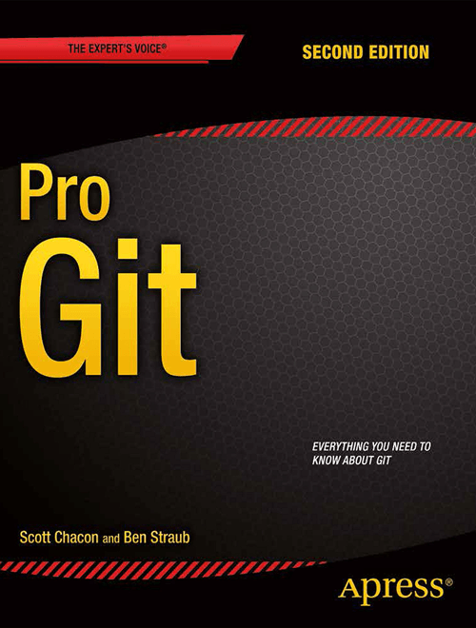](https://git-scm.com/book)

[**Pro Git**](https://git-scm.com/book)

By Scott Chacon and Ben Straub

[**Mastering Git**](https://www.packtpub.com/application-development/mastering-git)

By Jakub Narębski

* [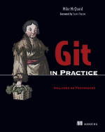](https://www.manning.com/mcquaid/?a_aid=MikeMcQuaid&a_bid=5688bbf4)

[**Git in Practice**](https://www.manning.com/mcquaid/?a_aid=MikeMcQuaid&a_bid=5688bbf4)

By Mike McQuaid

* [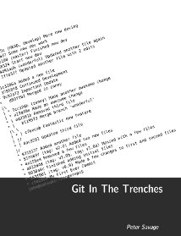](https://cbx33.github.io/gitt/)

[**Git in the Trenches**](https://cbx33.github.io/gitt/)

By Peter Savage

[**Git: Version Control for Everyone**](https://www.packtpub.com/git-version-control-for-everyone/book)

By Ravishankar Somasundaram

[**Git Essentials - Second Edition**](https://www.packtpub.com/application-development/git-essentials-second-edition)

By Ferdinando Santacroce

[**Git Version Control Cookbook - Second Edition**](https://www.amazon.com/dp/1789137543)

By Kenneth Geisshirt

* [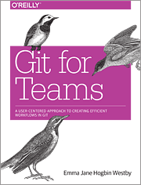](http://gitforteams.com/)

[**Git for Teams**](http://gitforteams.com/)

By Emma Jane Hogbin Westby

* [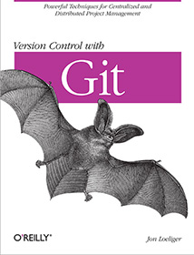](https://www.amazon.com/Version-Control-Git-collaborative-development/dp/0596520123)

[**Version Control with Git, 2nd ed.**](https://www.amazon.com/Version-Control-Git-collaborative-development/dp/1449316387)

By Jon Loeliger & Matthew McCullough

* [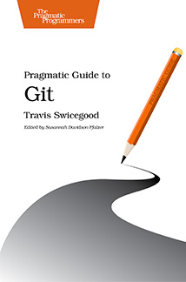](https://www.pragprog.com/titles/pg_git/pragmatic-guide-to-git)

[**Pragmatic Guide to Git**](https://www.pragprog.com/titles/pg_git/pragmatic-guide-to-git)

By Travis Swicegood

* [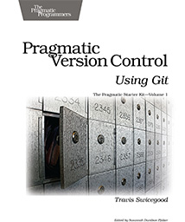](https://www.pragprog.com/titles/tsgit/pragmatic-version-control-using-git)

[**Pragmatic Version Control Using Git**](https://www.pragprog.com/titles/tsgit/pragmatic-version-control-using-git)

By Travis Swicegood

* [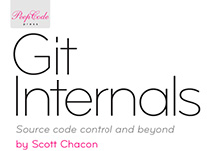](https://github.com/pluralsight/git-internals-pdf/releases/download/v2.0/peepcode-git.pdf)

[**Git Internals Peepcode PDF**](https://github.com/pluralsight/git-internals-pdf/releases/download/v2.0/peepcode-git.pdf)

By Scott Chacon

[**Git Version Control Cookbook**](https://www.packtpub.com/application-development/git-version-control-cookbook)

By Aske Olsson and Rasmus Voss

* [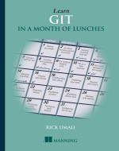](https://www.manning.com/books/learn-git-in-a-month-of-lunches)

[**Learn Git in a Month of Lunches**](https://www.manning.com/books/learn-git-in-a-month-of-lunches)

By Rick Umali

[**Version Control with Git and GitHub**](https://www.packtpub.com/application-development/version-control-git-and-github)

By Alex Magana, Joseph Muli

**Videos**

* [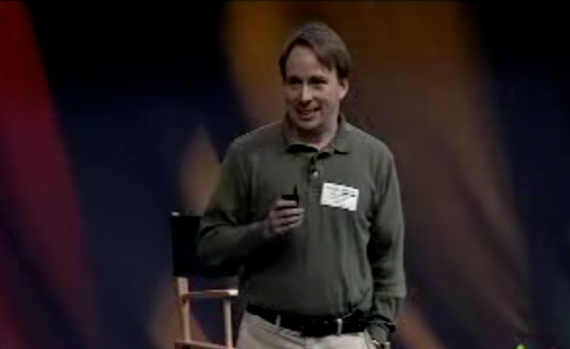](https://www.youtube.com/watch?v=4XpnKHJAok8)

[**Tech Talk: Linus Torvalds on Git**](https://www.youtube.com/watch?v=4XpnKHJAok8)

Linus Torvalds visits Google to share his thoughts on Git, the SCM system he created.

* [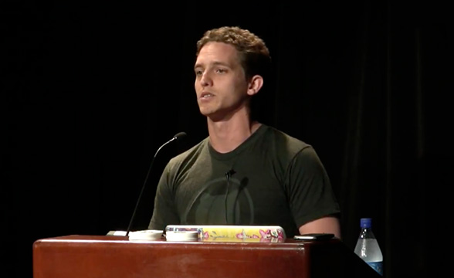](https://www.youtube.com/watch?v=ZDR433b0HJY)

[**Introduction to Git: Scott Chacon**](https://www.youtube.com/watch?v=ZDR433b0HJY)

This talk introduces the Git Version Control System by looking at what Git is doing when you run the commands you need to do basic version control with it.

**Courses**

* [**Git: Mastering Version Control**](https://www.packtpub.com/application-development/git-mastering-version-control)

By Ferdinando Santacroce, Aske Olsson, Rasmus Voss and Jakub Narębski

* [**Git Complete [Video Course]**](https://www.packtpub.com/application-development/git-complete-video)

A definitive, step-by-step guide to Git with easy to understand examples

* [**Git: Version Control Made Easy**](https://www.packtpub.com/application-development/git-version-control-made-easy)

Use the powerful features of Git in your projects

[About this site](https://git-scm.com/site)  
Patches, suggestions, and comments are welcome.

Git is a member of [Software Freedom Conservancy](https://git-scm.com/sfc)